***Oracle PL-SQL Course***

***Lesson 01***

**The Need Of PL-SQL:** **We need PL-SQL for run complex query and many conditions with sample way and that’s can run easy with programmer language like PL-SQL**

* **Example: If some one ask from us to update table salary but with many conditions like if the employee in department 1 increases the salary by 20%, if employee in department 2 increases the salary by 10%.... etc. Here is the problem in SQL we don’t have something like loop or if statement and that can be in programming language like JAVA, KOTLIN and PL-SQL.**

**PL-SQL Block Structure:**

* **DECLARE(Optional):** Here we can define the variables, cursors and user-defined exceptions
* **BEGIN(Mandatory):** Here we start write or SQL Statements and PL-SQL Statements.
* **EXCEPTION(Optional):** Here is the action to perform when there is an errors.
* **END(Mandatory):** Here we close and end our Block.

**Example** SET SERVEROUTPUT ON; -- We use this to print on the screen on oracle developer.

-- Lets start and make the first program like any programmer language.

BEGIN -- Here starts the Block.

dbms_output.put_line('Hello, World'); -- Here we tell the Serever to print this words.

END; -- Here close or ends the Block.

/

**Example2:** DECLARE

n1 NUMBER; n2 NUMBER;

RESULTS NUMBER;

BEGIN

N1 := &Enter_number1;

N2 := &Enter_number12;

RESULTS := N1 + N2;

dbms_output.put_line( 'The Result is: '||RESULTS);

END;

/

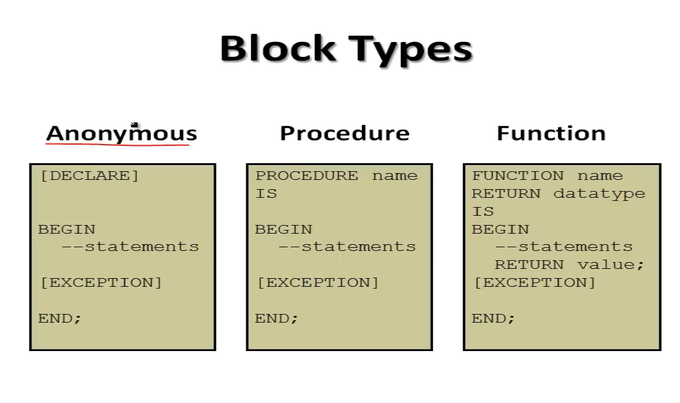

***Lesson 2 Variables P1***

**Variable:**

* Must start with letter.
* can include letter or number.
* can include spac char.
* must contain no more than 30 char.
* must not include reserved words in oracle.
  + Example: “” SET serveroutput on;

DECLARE

v_first varchar2(30) := 'Ask Gad';

v_number number;

v_date date default sysdate;

v_bool boolean:= true;

v_const CONSTANT number := 29; -- we cant change this after with made it.

BEGIN

v_first:= 'Nader';

v_number:= 20;

if v_bool

then

dbms_output.put_line('My name is: '|| v_first||' Today is: '||v_date||' Iam '||v_number||' years old.');

v_bool:= false; end if;

if v_bool

then

dbms_output.put_line('My name is: '|| v_first||' Today is: '||v_date||' Iam '||v_number||' years old.');

else

dbms_output.put_line('The v_bool is false');

end if;

END;

/ ””